# Chapter 3.

Sheet

24

NAU 17 21 32 000 EN

Performer

Chykurov M.V.

Supervisor

Khomenko V.A

Normcontrol

Radishevskij M. F.

ANALYZIS AND REQUIREMENTS SPECIFICATION

Letter

Sheets

36

SE-616 8.05010302

Department of SE

# MAIN APPLICATION AND USER PORTAL DESIGN

## Description of architecture in process of development.

The following system modules has to be developed and defined (Fig.3.1.):

1. Flight simulator – system that provides flight simulation, gathering data and data transition.
2. Main application server – server with deployed main application WAR file and possibility to connect to database.
3. Local station or laptop – station or laptop with active connection to local network and connection to main application.
4. Database – contains data of all entities and simulation record values.
5. User portal server – server with deployed user portal WAR file and possibility to receive data from database.
6. Common user laptop or computer – computer with internet connection and internet browser.

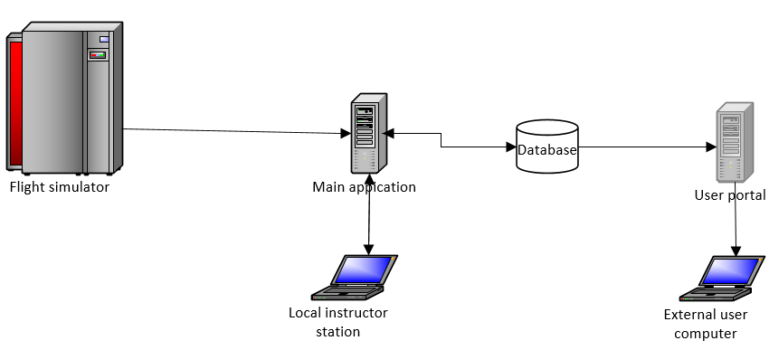

Fig.3.1. Structure architecture diagram